***User Guide For Maine Affordable Housing Coalition (MAHC) Affordability Dashboard***

**Overview**

This tool is designed to answer two questions:

1. **W*here is subsidized rental housing in Maine?*** both geographically and by type of program
2. ***How many households by county can afford various types of housing?***

The data queries a point in time file of between 41-42,000 households from MaineHousing.org as of 9/2022. MaineHousing.org has consolidated data on multiple programs, including USDA/Rural housing. Please note, this is a point in time view, and is showing the location of the household (e.g., Section-8 voucher is mobile). Specific addresses are hidden for security reasons. For LIHTC or other mixed programs, only the number of subsidized units are listed.

**To get started:**

1. Email [info@mainehousingcoalition.org](mailto:info@mainehousingcoalition.org) to receive the Power BI affordability dashboard file.
2. **You will need the free Microsoft Power BI** **Desktop software to open the dashboard.** If you do not have that installed on your computer, download it for free at: <https://powerbi.microsoft.com/en-us/desktop/>
3. In Power BI, o**pen the dashboard file you will get emailed called** “MAHC’s Affordability Dashboard”
4. If you haven’t used Power BI previously, you may also need to **adjust your settings to view the dashboard map**. In Power BI, go to
   1. “File” menu 🡪”Options and Settings”
   2. “Options” 🡪 “Security”
   3. And then check the “Map and Filled Map Visual” box to enable the filled map view

Once you have opened the file, the dashboard has two sets of data to explore that answer the two research questions:

1. ***Where are the subsidized households in Maine, by geography and by program?*** This is formatted as a map, and drop-down Q&A data in a table.
2. ***How many households in my county can afford which types of housing?*** This is formatted as a bar graph with a table beneath estimating the percentage of households who cannot afford a certain type of housing.

**Details on how to use the dashboard:**

1. ***Where is subsidized rental housing in Maine?***

This map shows over 41,000 locations as of 9/2022. This is a consolidated file that includes USDA/Rural Development data (Maine Housing consolidated the data for us). While many housing-programs are location based, Section-8 voucher programs are typically mobile vouchers. Which means that we know where the household lived when the voucher was issued, but it’s not certain where they reside while using the voucher as of this writing. Because nearly 30% of housing subsidies are mobile, we talk about subsidized households not structures.

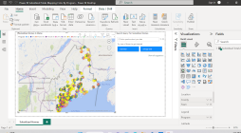

Figure 1.1

This initial display will show you a map of the entire state of Maine. The programs are color coded (e.g., yellow is Section 8 mobile voucher). The pie charts are showing multiple programs in one geographic location.

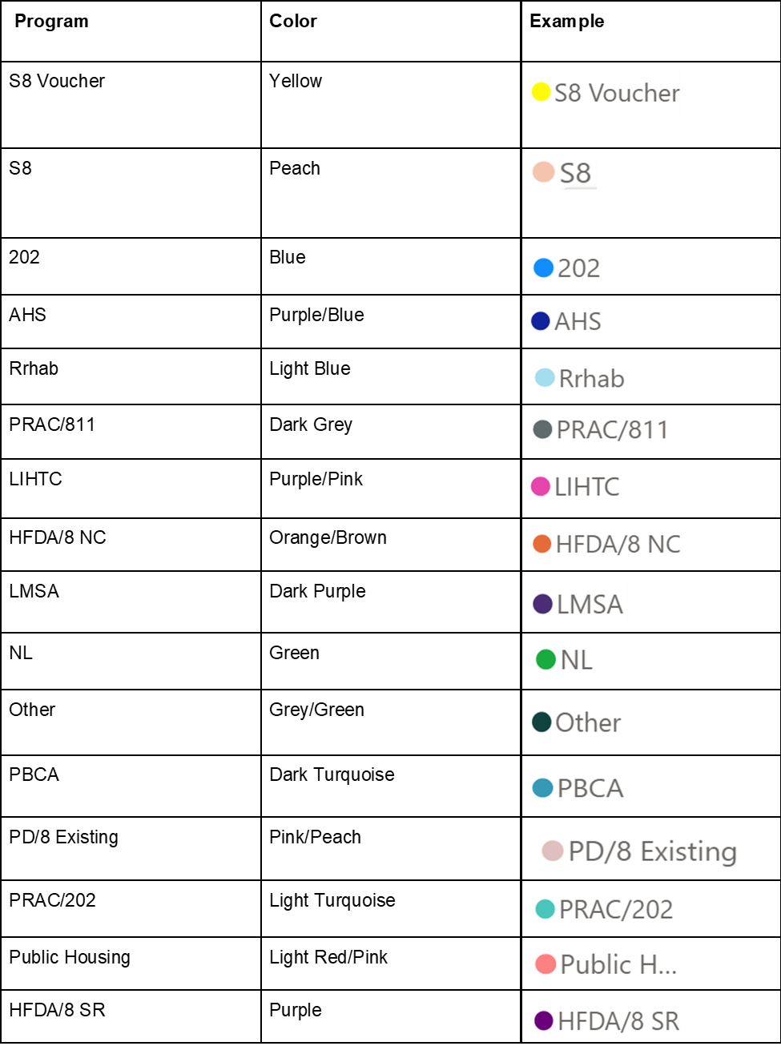

Methods of interacting with the Subsidized Housing data include:

* By placing the **cursor over the pie** chart of interest, additional data on the mix of housing assistance can be gained in a pop-up box. Please note, for places with many programs, the query function below may be easier to use.
* **Use the search query menu to examine additional underlying data in a table format**. For example, you could search *S8 Cumberland County.* This will prompt you with a data table, showing all S8 programs in Cumberland County.
* **The search query menu can also be used for refined mapping**. By entering the search terms and clicking on the map, this will map for example, S8 in Cumberland County.

**TIPS**

* When mapping and using the “subsidized housing” data - you must clear one query to enable the next. To do this, delete the words in the query box(es) and hit “enter”.
* To get the mapping feature to work, click on the map.
* If you get an error message “Map and filled map visuals aren’t enabled for your org. Contact your tenant admin to fix this”. To fix this re-download the **DESKTOP** version of Power BI and then follow #4 in the “Get Started” box on page 1 of this User Guide.

***B. How many households in my county can afford which types of housing?***

* At the bottom of the dashboard is a tab for each county just like in an excel spreadsheet.
* If you select the county you desire, it will show you the **distribution of household income**. This is the share of households in each income group in that specific county. The data is from the American Community Survey (ACS 2020). Please note, ACS does not use “even” income groupings ($5,000 increments at the lower income – left hand side, moving to $50,000 increments at the right-hand side of the graph).
* By mousing over a blue bar, you can see a drop-down box of the **% of households and the number of households in each income group.** This is useful if you wish to change assumptions about housing costs and resulting affordability.
* At the bottom of the graph is a **table showing three types of housing costs and the percentage of households in that county who would find these housing types unaffordable.** Fair Market Rent **(FMR)** comes from HUD via Maine Housing and is as of 10/2022 for a 2-bedroom apartment; **Median Sales Price** is the median price for the most recent quarter with data (Q3 2022) in that county and comes from the National Association of Realtors (NAR); The **new construction cost** is without land and comes from both conversations with MAHC and National Association of Home Builders (NAHB for 2022).

**FAQ:**

**Q: Is there more information on what some of these programs might be?**

A: The program abbreviations are MaineHousing’s codes. Here is a bit more detail:



**Q: How do I see just the subsidized housing locations in my town or county?**

A: Use the search query function to ask for just your county or town.

**Q: How do I see just the elderly programs?**

A: Use the legend and search query function to ask for just elderly programs.

**Q: How do I know which locations have vacancies?**

A: Go <https://www.mainehousingsearch.org/> It is an interactive tool that can remove locations with zero vacancy currently from the list of possible rental options.

**Q: What are the assumptions that went into affordability calculations?**

A:

* Fair Market Rent (FMR) is for a 2-bedroom apartment in each county and is a calculation that comes from HUD every year. This is showing 10/2022 estimates. To determine the affordability – we simply took that monthly rated divided by .3 (turned it into 30% of gross income) and multiplied by 12 months. This converts monthly rent, into annual income needed.
* Median Sales Priced Home is from the National Association of Realtors for Q3 2022 in each county. The affordability of homeownership varies significantly by household (depending on the person’s FICO score, debt-to-income ratios and other debts). It also depends on the towns mil rate for property taxes and interest rates. To adjust for local variability, we have used a 2.5x multiplier as a crude approximation of home-ownership affordability.
* New Construction (market rate – non-subsidized) costs are consistent across locations and building types (i.e., a unit of Mulli-family construction costs about the same price to construct as single-family home). The source of this data is MAHC’s seminar in 4/2022 on construction costs as well as National Association of Home Builders 2022 survey. The same 2.5x multiplier is used (housing cost divided by 2.5 provides a rough approximation of annual income needed).

**Q: Why do you use a 2-bedroom FMR rental rate? Aren’t there are lot of small households who would only need a 1 bedroom or studio apartment?**

A: While it’s true that there are a large number of small households in Maine, it is also true that FMR is the 40th percentile of rentals (i.e., below average apartment). These two unrelated assumptions may partially offset each other. Anecdotally it is very challenging to find an apartment at the FMR rate. Therefore, using a 2-bedroom rental, which would be appropriate for small families, seemed appropriate.

**Q: Why did you use Q3 2022 median sales price instead of the median for the entire calendar year?**

A: Q3 2022 is the most recent data available and is mostly lower than the calendar-year median numbers. There are two reasons why we use the lower Q3 number as a more conservative estimate: 1. Calendar year 2022 may have had a higher percentage of second homes earlier in the year. The mix shift may be contributing to the higher calendar year median sales price vs. Q3 median sales price. 2. As interest rates rose throughout 2022, the fall closings may have started to see lower sales prices. Therefore, we elected to use the lower Q3 median house price as the most recent available. For calendar year 2022 the median sales prices were higher in 13 counties then it was in Q3 2022 – with 1 county about the same; Penobscot County had a slightly lower 2022 number vs. Q3 and 1 county had no data for 2022 on Maine’s Association of Realtor website. Q4 data was not yet listed on the NAR website when the dashboard was built.

**Q: Why does the FMR I see on my current report, look different than the FMR you’re showing?**

A: The time periods could be different. Also, in some years and some places HUD has allowed a 40th percentile over-ride (i.e. allowed the use of the 50th percentile which implies higher subsidies from the government). The data we’ve shown was the 40th percentile FMR by county on 10/1/2022 sourced from MaineHousing.org. Also, some SMA’s have their own FMR. For consistency we are using county level data.

**Q: I’m having trouble accessing the data, is there someone I can contact?**

A: Yes, [info@mainehousingcoalition.org](mailto:info@mainehousingcoalition.org) or [Jacob.d.curtis@maine.edu](mailto:Jacob.d.curtis@maine.edu) or [Sarah.j.sturtevant@maine.edu](mailto:Sarah.j.sturtevant@maine.edu)