NB: This is an updated version of Field Notes originally published on 1/7/2025. There are three important clarifications around modular licensing:

1. Corporate-level modular licensing does exist: The applicant for modular licensing has to show two-years of personal experience with another license holder, however, the license is a corporate one.

2. Construction under MUBEC using modular components does not require an installers license.

3. Most modular construction in the state is following the modular-specific-subset of residential codes, which reportedly provide flexibility critical to improving affordability.

More complete licensing notes are shown at the end in the appendix.

As a result of multiple conversations, the February MAHC meeting on this topic and the subsequent inaugural offsite-construction-working-group meeting on 3/5/2025, the modular recommendations have evolved slightly. 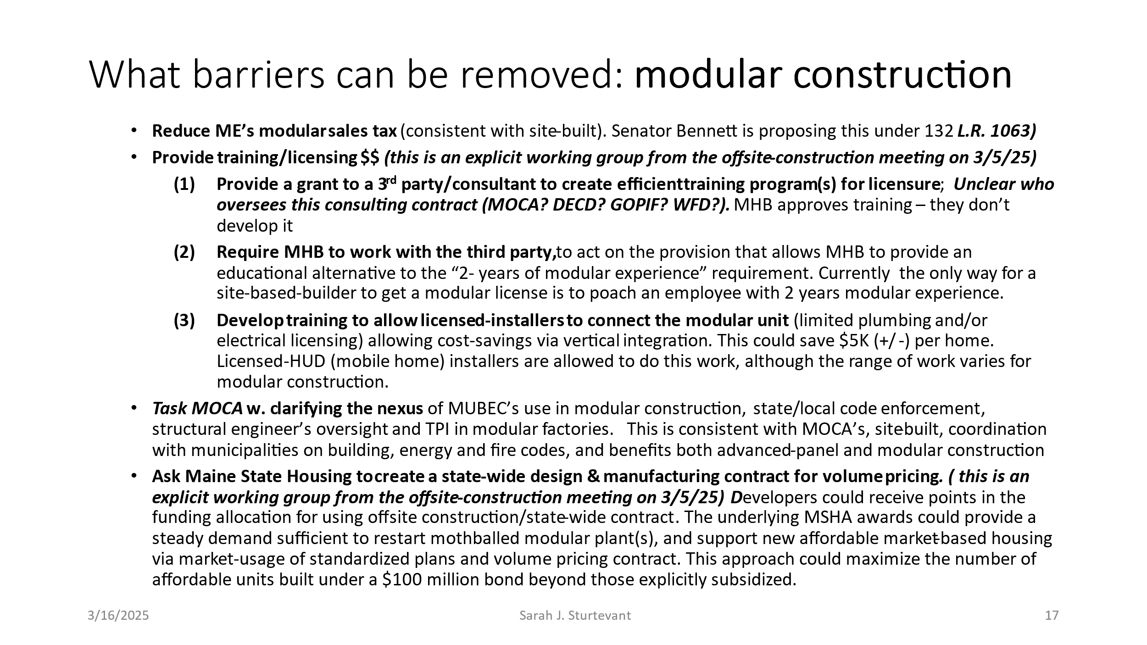

--------------------------------------------------------------

Maine’s housing production goal, of building more than 80,000 housing units by 2030, represents an enormous increase in construction. The need is so large that **bold process changes are needed to meet it**, which in turn requires public/private collaboration to safely make those changes. The establishment of Maine’s Office of Community Affairs promises a moment-in-time to achieve that collaboration.

**Exterior wall** **panels** (framing, moisture barrier and sheathing) 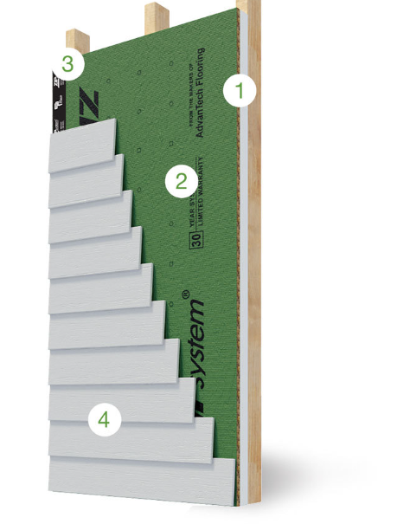

**Insulated Panels:** (exterior panel + interior insulation and chase for mechanicals) framing inspection done in the factory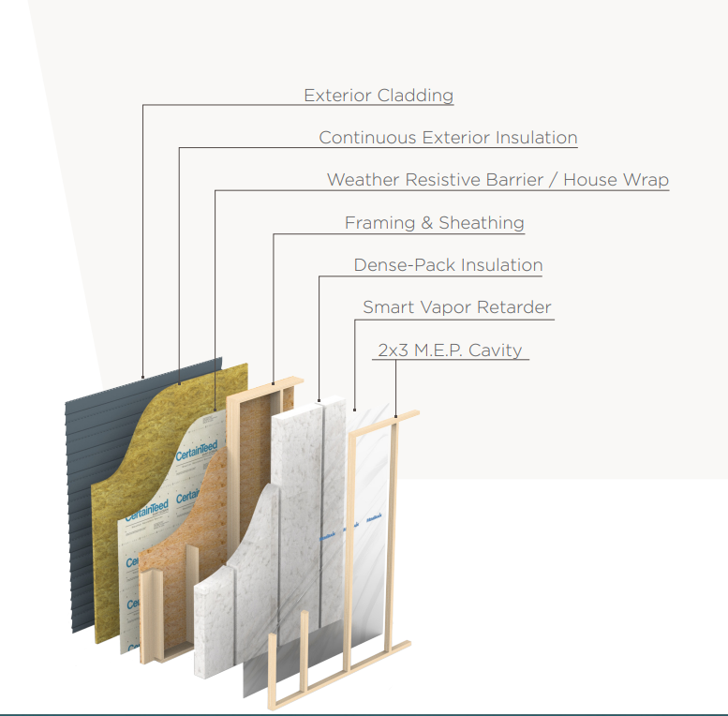

**Modular components**

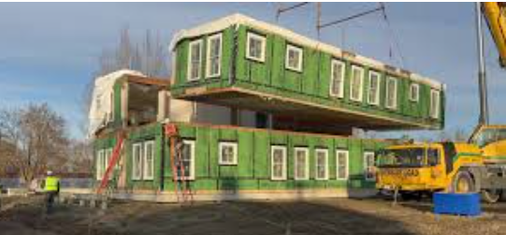

Factory Components:

Maine struggles to build a few thousand homes a year – of which ~1000 homes are affordable. Therefore, as a starting point, we wondered if changes in construction methods could improve affordability of newly constructed housing in Maine? Might that in turn prompt private-market, lower-cost, housing to be built and at the same time help stretch scarce subsidies further for the lowest income households? **Might greater adoption of new(er) construction technology bridge the gap between construction costs and what most Maine households can afford?**

**Executive Summary: The answer is a qualified “yes”.** **Newer methods can reduce costs to an extent. However, there are many barriers**. Construction technology alone, will not completely solve the problem. New(er) technology is an important tool in the tool kit and it is worth addressing the remaining barriers to broaden adoption.

**Uninsulated exterior wall panels are** widely used, and therefore no additional cost savings is likely.

**Insulated panels**, where framing inspection is done at the factory by Maine-licensed Third-Party Inspectors (TPI), does have room for additional adoption and therefore cost savings. The largest hurdle to broader adoption is industry knowledge – for example greater training around the nexus of factory TPI, local code enforcement officers (CEO) and reliance (and costs) for structural engineers’ on-site support. Both cost savings and reducing barriers to broader adoption are possible should MOCA engage in training and coordination between state and local building officials.

**Modular components have** the most promise and the most barriers. Depending on whether the state is able to reach a higher level of standardization, Maine could see cost savings of 10-35% of total costs from the greater utilization of modular. Barriers are extensive, including the same code-enforcement issues as insulated-panel construction; double sales tax is charged on modular units and the licensing requirements have not coordinated with training programs resulting in lack of human capacity. Overall, there is a lack of industry knowledge about the opportunity of factory-built components and a related substantial inertia.

*The analysis, opinions and views expressed herein are solely those of the author and do not necessarily reflect those of MAHC or its members.*

**Details:**

Below are three sets of factors to consider based on Fall 2024 interviews of Maine General Contractors; Manufacturers of Panels/Modular; Developers; Industry groups; State Standards/Licensing Board and Architects/Designers:

1. **Root Causes:** A refresher on “why is building lower-cost, affordable, housing so challenging?”
2. **Current status** of newer construction technologies such as panelized construction and modular and what are the pros and cons of each?
3. **What can be done**: what can Maine do to improve the odds of higher adoption rates, in order to encourage lower-total-construction-costs and thereby start to move towards the housing production goals outlined by HR&A under LD2003?

**Root Causes: Why is it so hard to build lower-cost (aka affordable) new homes?**

Housing construction is a complex ecosystem. There are dozens of organizations (public and private) that impact the construction of a single home. Each of these entities can have a different funding source and business model. Changing incentives is extremely challenging and requires intense collaboration. For example:

* **Each new development is its own virtual company**, formed for a period of time to complete the work and share the risks. Often a singular LLC is set up for a single address. This could be thought of as a **“coordination tax” and it is very high.**
* There are **24 subcontractors,** on average**,** per new single-family home and it takes about 1 year to build. Multi-family has an even higher number of “subs” and takes closer to **2 years of construction after 3-5 years of permitting/approvals.** Permitting takes much longer than construction (source NAHB).
* The proliferation of requirements has resulted in **extreme specialization** – both in the number of “subs” – and even within a “sub” (e.g. drywall or flooring may have 3 different teams of specialists). The **time lost from coordinating schedules is another example of a high coordination tax.**
* The ecosystem extends well beyond what most would think of as a construction worker – from surveying and engineering, title work, legal and accounting, distributors, transportation, earthwork – to repairing heavy equipment. **Construction has a high jobs multiplier.** Meaning that for every 1 construction job, nearly 4 other jobs are created and need to be filled. Increasing labor capacity is extremely challenging at all levels.
* **Lack of capacity is endemic. There are shortages in number of companies who will bid** – as well as number of workers at each of those companies. **Our educational system tends to focus on skills training (i.e. preparing someone to be an employee) not on creating new companies.**
* “A”affordable developers who build for low and extremely-low-income residents have become creative, often finding 10 or more layers of financing to support a project. This **highly complex capital stack also adds costs**. One developer suggested that they have to hire “one full-time office worker per project, just to handle the reporting and compliance requirements”.

Given all this, not surprisingly, nationally **construction productivity has plummeted** over many decades (source McKinsey) **and** **Maine’s construction productivity is 14% below the national average** (source 6/2023 Maine DECD construction industry profile)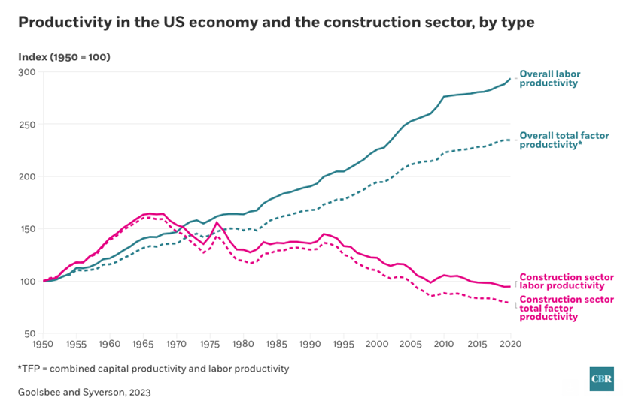

By some measures – as much as 40.6% of total development costs are from increased regulatory burdens over time (source: NAHB’s small, national, survey). To validate this nationwide study, for relevance in Maine, is not so easily done. However, Maine’s soft costs are typically thought of as ~20-30% of total costs and many soft costs are to meet regulatory requirements of some sort. Hard costs also have regulatory costs like OSHA. Directionally, this national data seems roughly correct for Maine and is a large component of total construction costs, thereby lowering the number of units that can be built at an “affordable level”.

These challenges are not unique to Maine. However, what is additionally challenging for Maine is both the age of her workforce, and the small size of households. Maine overall has a high percentage of 1 person households (medium blue on map to the right ) at 29-31.2% of households (vs. national average of 27.6%).

**Maine has a high percentage of 1 person households: Census** **Data**

MaineMaine

Somewhat surprisingly, the most urban areas of Maine do not have the highest rate of small household size. The Dark Blue areas are more rural parts of Maine where 31-70% of all households are 1 person households. According to the Production Goals Report, many of the areas in Maine that need the highest % increase in new housing construction, live in regions with a very high percentage of 1 person households.

**It is extremely challenging from both a construction-cost, and “affordability” perspective, to house a single-person household.**

For example, using a number of assumptions, my ballpark estimate of “affordable construction cost” is relating income to a theoretical new construction budget. A **single full time minimum wage worker has a construction budget of roughly $75,000. Compared to an average construction cost of a basic apartment at roughly $375,000 – or 5x what a full-time minimum wage worker could afford**. Even the median income HH cannot afford the average construction cost of a new basic rental or SF home ($280-300K is what is affordable vs. $375-468k construction costs). Worth noting the average salary of a Maine construction worker in 2022 ($64,244) is below the Maine median HH income of $75,160. Meaning that a **construction worker, on average, cannot afford the housing they are building.**

Actual construction costs vary; however, they are consistently 1.5-5x what is affordable.

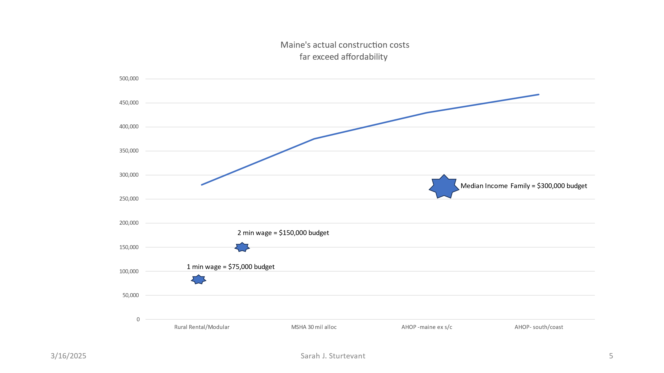

**2. Will greater adoption of construction technology help bridge the cost: affordability gap?**

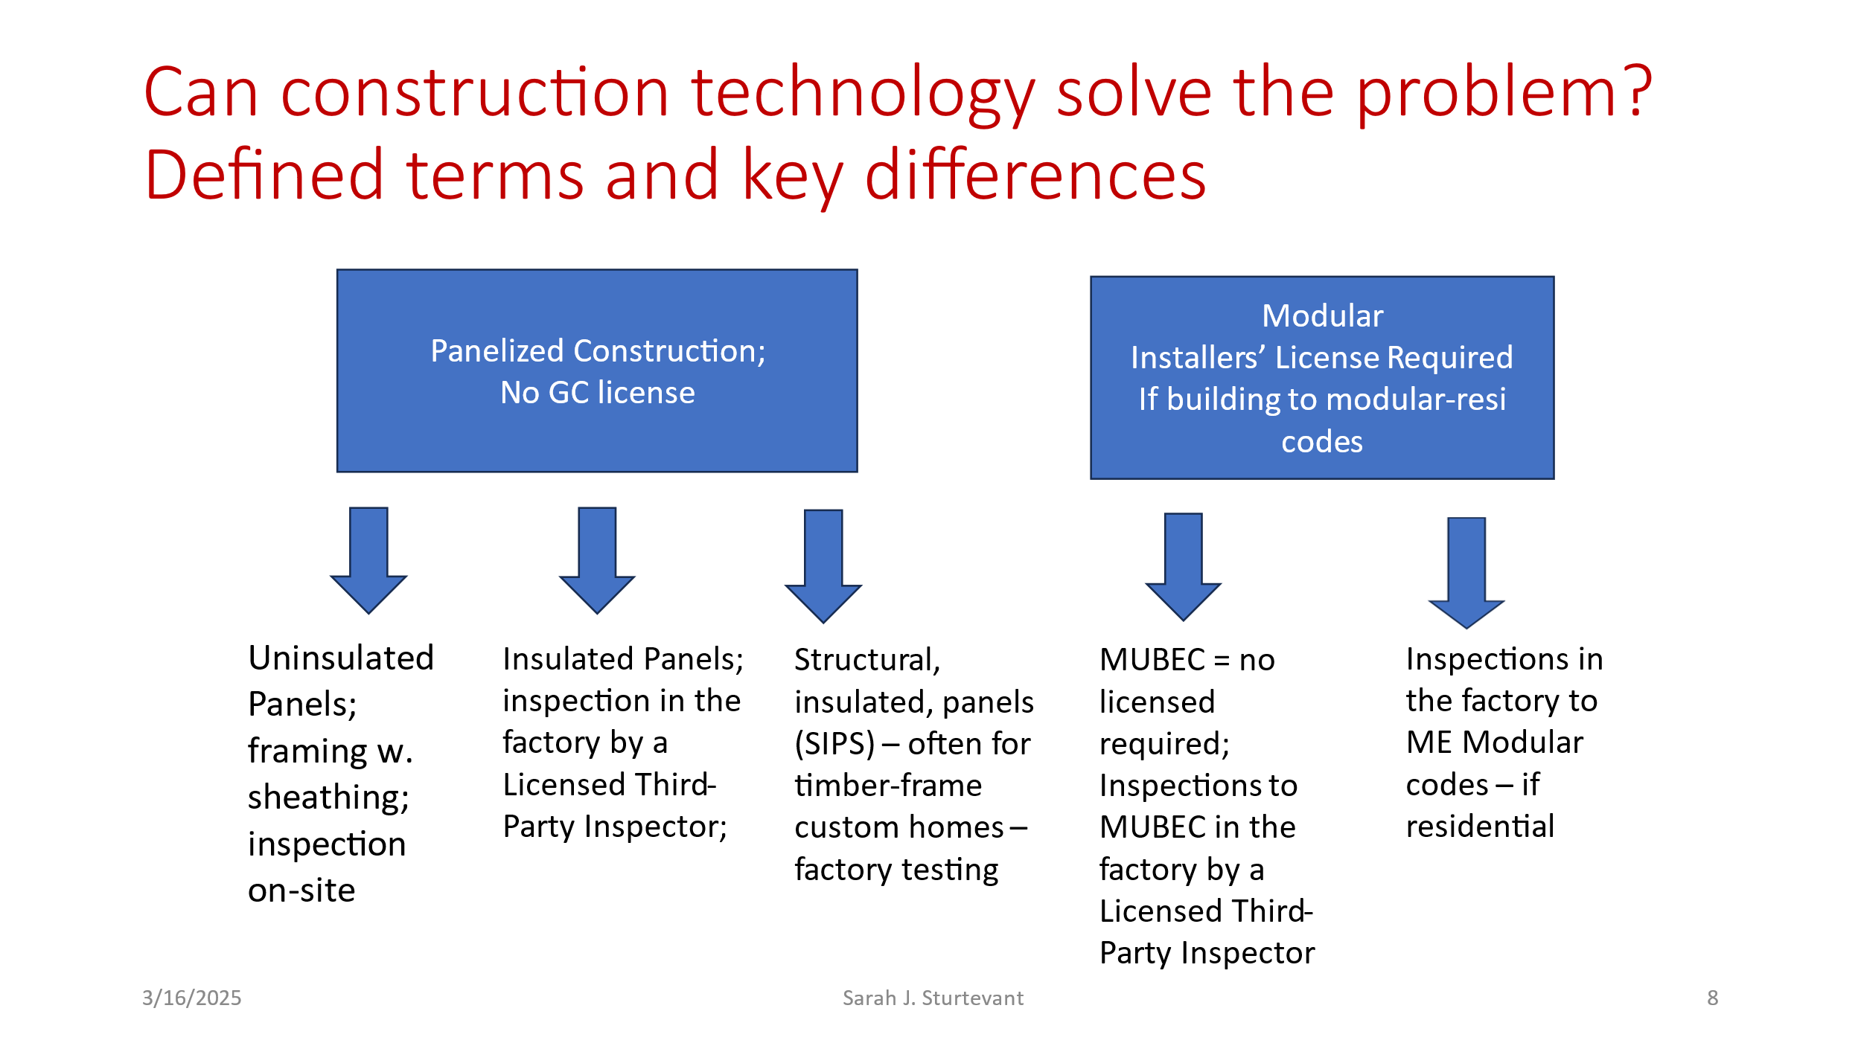

Uninsulated panels, including ones that have exterior foam-core or zip-panel construction, are widely used. Which means that any cost savings is already baked-in. These types of exterior framing + sheathing + moisture-barriers are widely available and do not change the code-enforcement inspection process, vs. insulated-wall-panels and modular which both have licensing and code-enforcement challenges.

There is more room for adoption of insulated panels, but there are also more barriers. Modular construction for multi-family is the least utilized technology, it is growing with rural rental projects and othe rs – and some of the barriers faced overlap with those of insulated-panels.

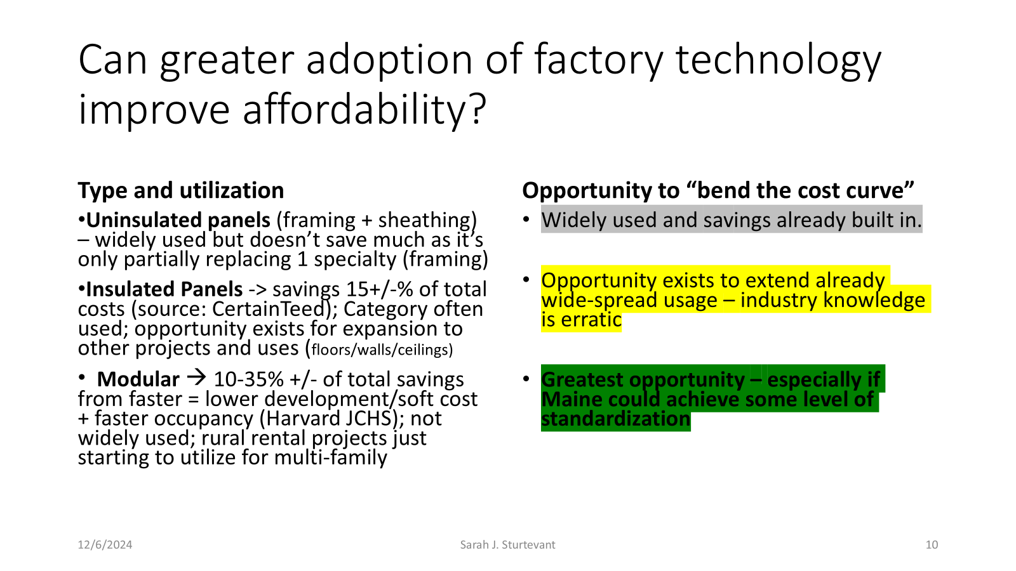

Key barriers are code-enforcement and licensing processes.

Modular construction requires an extra level of licensing from the Manufactured Housing Board (MHB) with currently no training “feeder” program to create more licensed-installers. There is also no way a large general contractor can become licensed *“as a company”* for modular installation. The largest GC companies in Maine would likely want their licensing secure, prior to bidding on a project, without worrying about employee turnover. Creating a path for corporate licensure is critically important in my view. There are also 2 layers of sales tax charged on modular – once on the materials used (just like site-built) and then another layer of sales tax charged when the modular-component is delivered.

Inspections and code enforcement is also an issue. The nexus between Maine-licensed-third-party-inspections (TPI) in the factory, structural engineer oversight and local code enforcement officer (CEO) inspections needs coordination, codification, simplification and training. There have been instances where the builder pays for duplicate inspections: factory-inspection and local inspection as the town is unwilling to accept a licensed TPI’s oversight. Other times the builder must include a significant cost for the structural engineer to be present on site, helping coordinate local CEO inspections. And others where the town requires “their own” TPI (third party inspector in the factory – being unwilling to accept the licensure of any TPI in Maine). This complex code-enforcement dance, while well intentioned, adds to costs and risks – and is a barrier.

The pros outweigh the cons for greater adoptions of both insulated-panels and modular, however, industry practices are slow to evolve. The cost savings potential for modular components is much higher, however, so are the barriers. 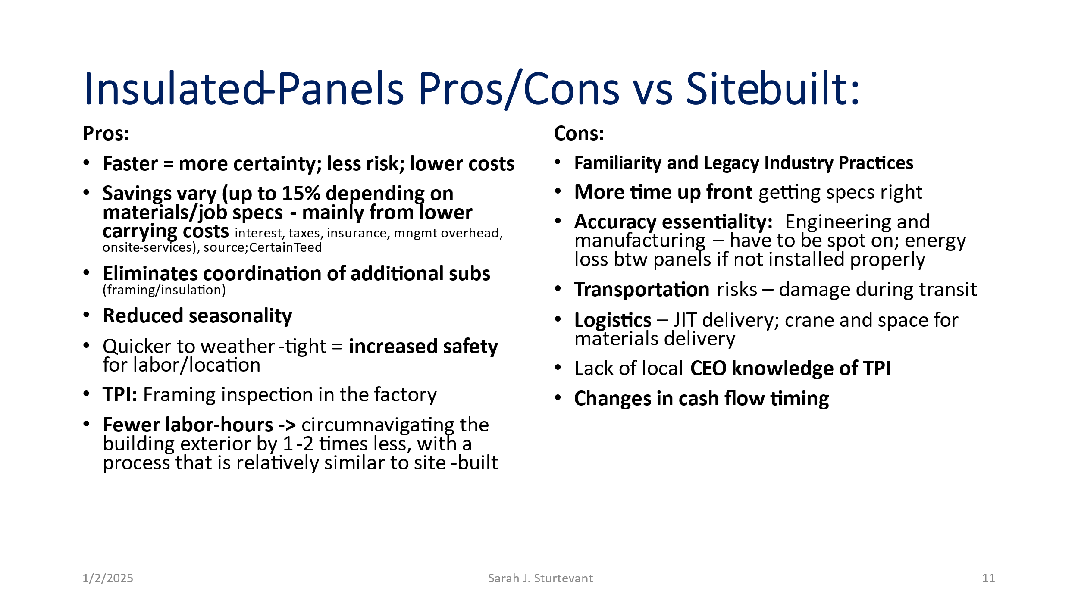

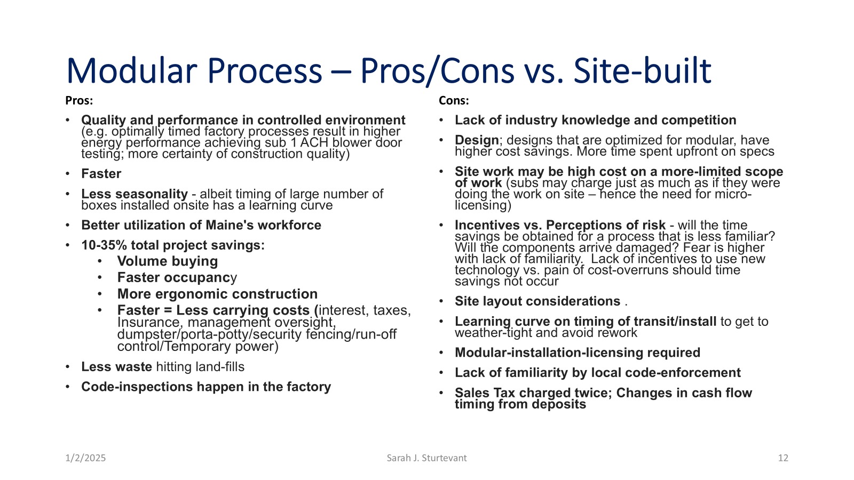

**What can be done?**

**All types of construction:**

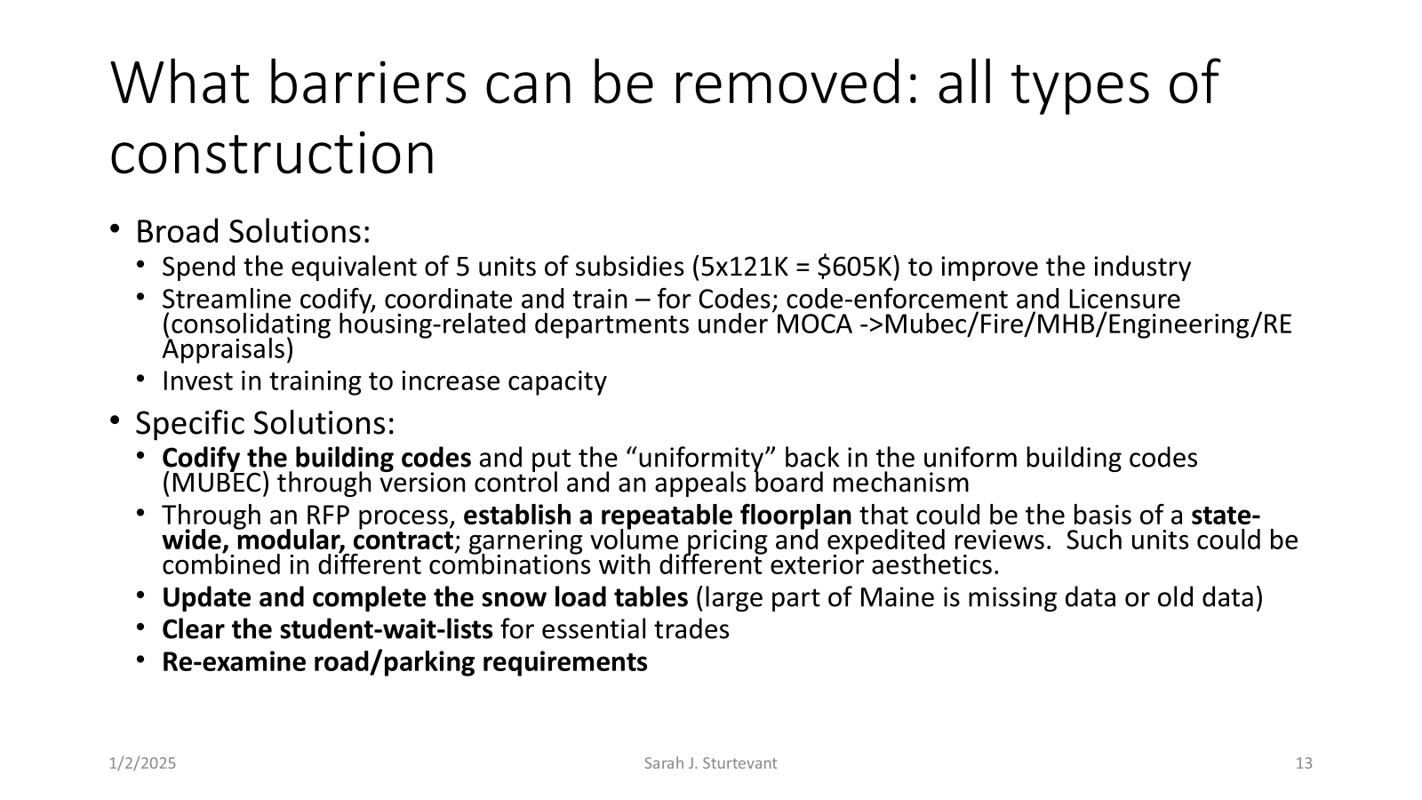

Snow load tables are but one example of the need for greater public/private coordination. Below is the map of the state. The areas in white have no snow-load data and are considered “case studies”, meaning extra engineering costs occur because each builder has to hire an engineer to do the assessment. Completing and updating the snow load tables would help the industry. Developers of the rural rental project in Madison, suggested that had they been able to use the neighborhing counties’ snowload table, they would have saved $100,000 on roof costs across 2 buildings and 18 units.

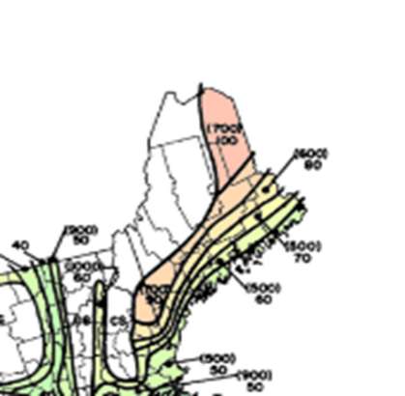

Another challenge with snowload tables (or the lack thereof) is that local codes often require a certain roof pitch obstenisbly for snow load safety. That single code, however, effectively prevents more affordable types of housing. Manufactured (mobile) homes and lower-pitched modular roofs (those with a low enough pitch to be shipped completed) generally are effectively prohibited by low roof pitch local codes. Constructing secondary roofs over manufactured housing, or higher pitched modular roofs which have to either be hinged roofs from the factory or completely built on site - all require extra site work, adding to costs and reducing affordability. The extra costs, of meeting these local codes, lowers access to affordable housing.

**Small Homes:**

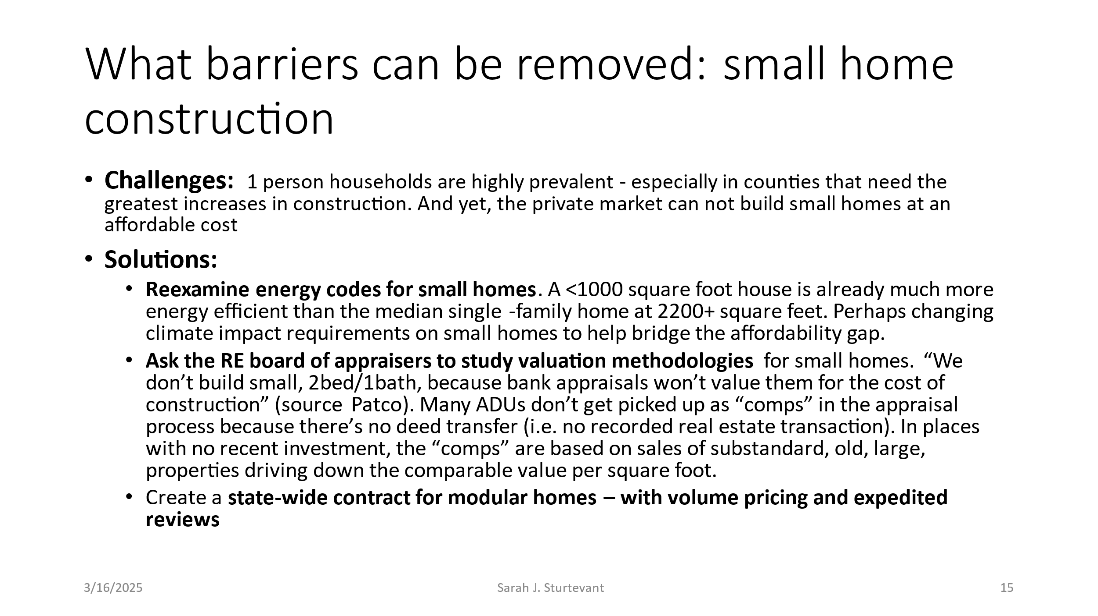

**Panelized Construction**

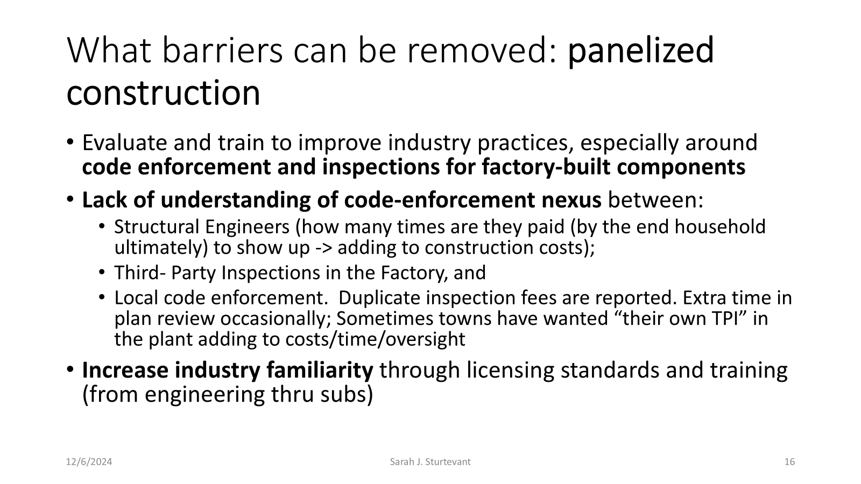

**Modular Construction**



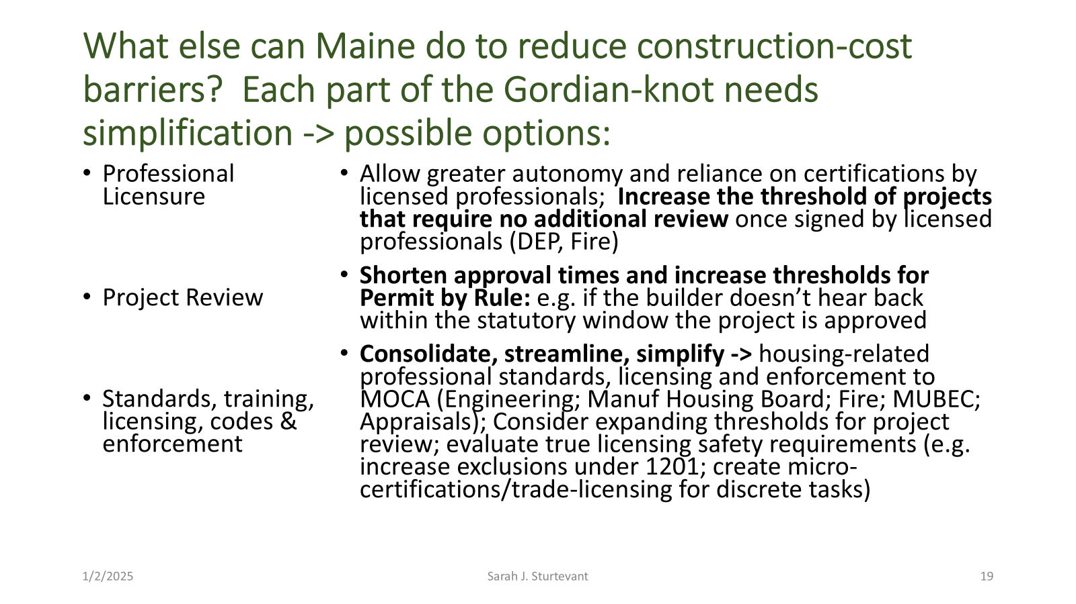

**Does Maine need additional factory capacity?**

Capacity is a hot topic nearly everywhere. However, different things are meant by different people. From the interviews conducted in fall 2024, **there does not appear to be a factory capacity shortage. There is a huge human-capacity issue and a “number of companies to bid” capacity challenge**. The state needs substantial new capacity at many levels:

1. Training programs; The **existing programs often need additional “seats”** to train students who want to enter the trades. I call this “clearing the student wait lists”.
2. Create **new programming that serve as feeder programs for licensed professionals, especially modular installation licensing** - combined with micro-licensing credentials to be created
3. If there are insufficient trainers – **consider asking the national guard to help recruit and establish a dedicated training center** (staffed with returning retirees?) which would be free to Maine residents
4. Task the educational programming in the state to **create business development programming for trades people who want to start their own companies**. The state is short of skilled/trained labor – as well as the number of companies available to bid on the work. Low competition = “charge what the market will bear” mentality.
5. **Fund additional staff** (together with reexamining the essentiality of reviews/licenses) at Maine housing-related departments
6. **Accept trade licenses from other states** (e.g. plumbing and electrical). Other states are accepting licenses from elsewhere as qualifying in-state

Below and in the appendix, are some key charts from 6/2023 Maine DECD construction industry profile. NB: the green section is somewhat misleading as it contains only workers self-identifying as residential (single family housing typically). Most multi-family construction would fall within the yellow “commercial” segment. Within the dozens of subcontractors needed for a new construction project – are the large dark-blue segment of contractors. Missing are architects, engineers, surveyors, realtors and housing developers, housing-finance workers, estimators, site planners, code enforcement, municipal and state workers for licensing, project and permit review. Combined Maine likely needs well over 40,000 new workers to meet its housing production targets.

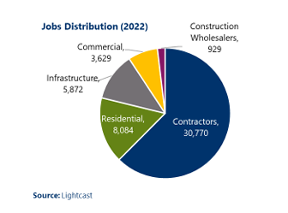

In summary, Maine needs to address 3 wickedly complex challenges:

1. **How can Maine encourage additional adoption of factory-components**? Factory-built housing and housing-components are more ergonomic and less weather sensitive, and therefore allows older workers to stay in the industry longer. It also has the promise of lowering construction costs. In turn, lowering construction costs, and streamlining processes, lowers risk and thereby has the greatest chance to restart the private market for lower-cost (aka affordable) housing construction.
2. **How can Maine encourage the creation of new companies** (see high concentration stats in DECD report) to expand capacity?
3. **How can Maine train 10’s of thousands of new workers? There** are 49,284 individuals involved in construction (and that leaves out many key pieces to the construction ecosystem). Training 40,000+ workers is akin to training a small army. Creative thinking is needed beyond how to add 100 seats to Maine’s CTE electrical programing.

Appendix:

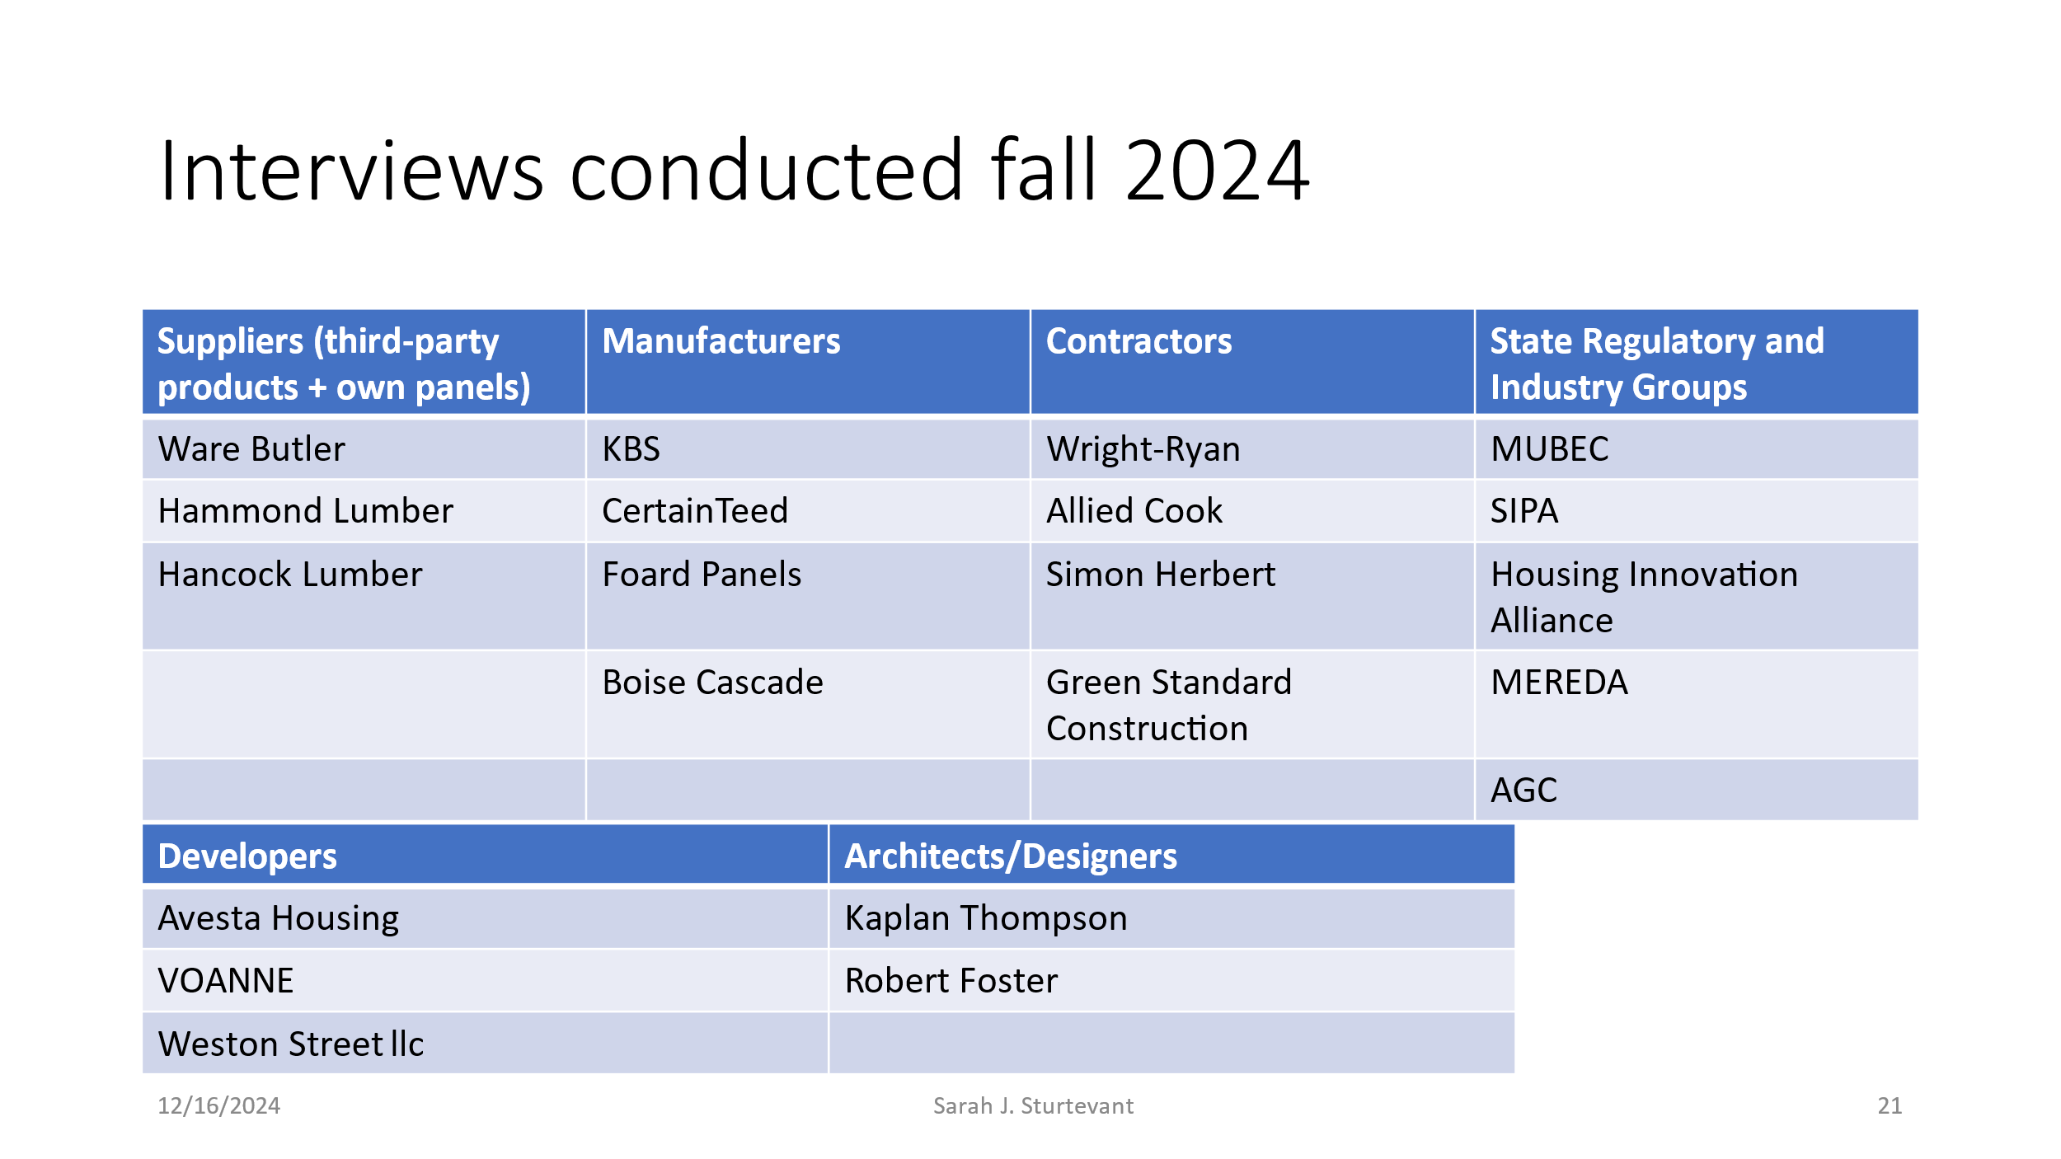

Assumptions and definitions:

1. Affordability is a defined term. Capital “A” affordable means housing that relies on public-subsidy through a variety of programs that provide housing for lower income households. Little “a” affordable means naturally occurring lower-priced, market-based units, often either provided through older housing stock or conventionally financed construction of units that are smaller in size.
2. Field Notes is the start of a conversation. It is not intended to be an exhaustive survey.
3. Translating affordable monthly housing expenditures (30% of income) to an estimate of construction costs supported by that payment, necessitates a range of assumptions. Chief among the assumptions are interest rates (Maine Housing’s first-time-buyer, APR of 6.495% was used at the time of this analysis); taxes and insurance. Including property taxes may seem excessive for some non-profits, however other landlords/owners would have to pay that expense – so I have included it to be conservative in these estimates.
4. My calculation of “implied affordable construction budget” presumed 1 full-time minimum wage worker, who would need an underlying affordable construction cost of $70-80,000. Updated as of 1/1/2025 to a min. wage of $14.65, a 1 minimum-wage-worker household would need to spend $762/month on housing to be affordable. This income presumes a 40-hour week and 52 weeks/year of employment, or $30,472/year in income. This is roughly equivalent to HUDS AMI estimate of a 1 person HH in Kennebec County at 50% AMI. Note the recent increase in the minimum wage only adds a little over $1000/year in income or an extra $312/year towards housing expenditures.
5. We included builders across types of housing. The affordability gap is not much different between multi-family and single family; nor between built-to-rent vs. built-to-own housing. Service costs, extra regs (ADA/fire) and occupancy costs for multi-family offset higher density land use benefits.

** 6 recent awards

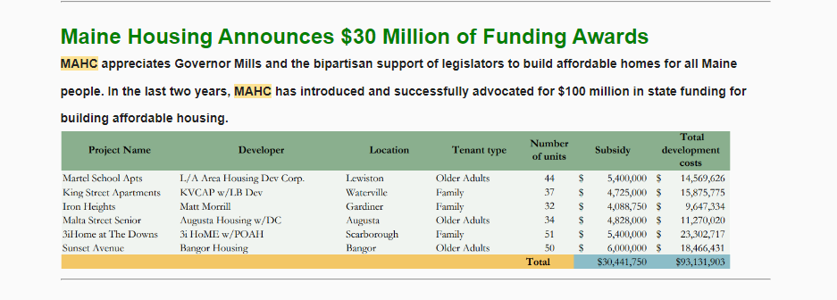

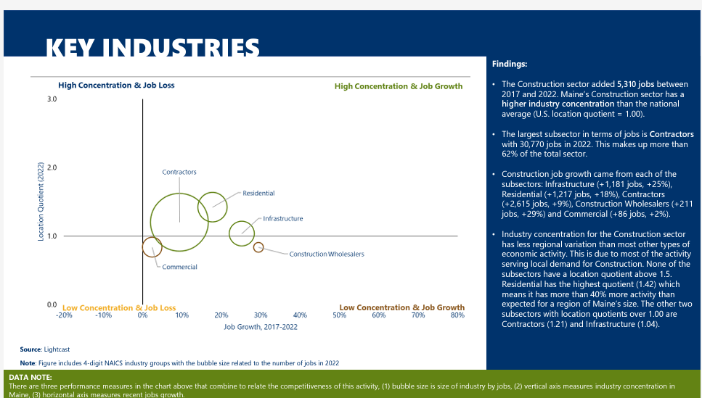

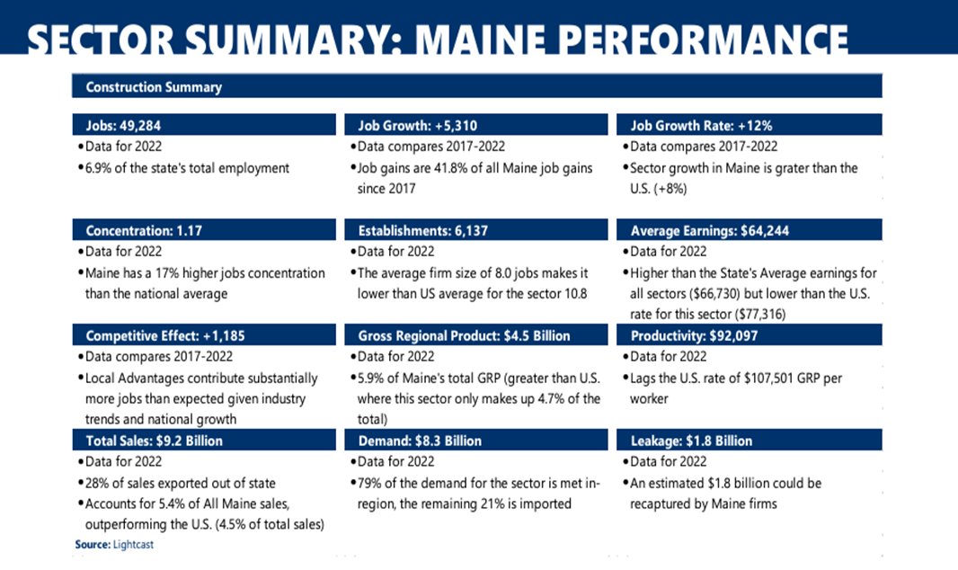

**A Deeper Dive into MHB’s Licensing of Modular Construction in Maine**

The Maine Manufactured Housing Board (MHB) has statutory jurisdiction over modular licensing for 1 and 2 family units and townhomes. MHB also has statutory jurisdiction over manufactured housing aka HUD-code or mobile homes.

Information came from MHB/OPOR staff (Peter T. Holmes and Joan Cohen). Working together, we have attempted to list, in layman’s English, what is required. The purple quotes are additional MHB/OPOR comments. Listed under “author’s observations” are my thoughts on what these facts have come to mean for affordable, modular, housing construction in Maine. The author’s observations are hers alone – and do not reflect those of OPOR, MHB or MAHC.

**Overview:**

Author’s observation: Oversight of modular construction in Maine roughly follows manufactured (aka HUD-code or mobile homes) processes and represents a consumer-product-liability mindset. The rules seem to mostly be geared for 1 home-buyer at a time, going to 1 dealer and buying a single home (duplex or townhome). There exists a modular developer-dealer license which is designed for developing multiple modular-unit projects. There are far more developers, than those with modular dealer/developer licenses. This specialized license is an additional hurdle in getting modular construction to “go mainstream”.

Modular rules do not work especially well for many larger scale developments, and “housing as a service”, built using modular construction. Maine is (1) moving towards pre-approved plans that incorporate many missing-middle, middle-density, building-types (beyond SF/MF distinctions), and (2) modular construction is seen as a way to efficiently address work-force shortages and reduce costs from faster construction and less seasonality.

Statutes and regulations designed decades ago, increasingly no longer fit an important emerging path forward for affordable housing.

Modular licensing requirements (without feeder training programs) have especially contributed to capacity shortages of trained set-crews and license-holders – particularly for those projects bigger than 1 house at a time.

**Modular Licensing Requirements:**

MHBs statutory licensing requirements apply only to single family, 2 unit & townhomes.

Commercial modular would be governed by MUBEC. There are no MHB licensing requirements for multi-unit properties following MUBEC codes.

OPOR: the MBH does not adopt the IBC since the IBC explicitly excludes 1 family; 2 family homes and townhouses.

MUBEC is the statewide code and applies to all residential construction except those with MHB oversight and log homes . Per statute, towns under 4000 are not required to *enforce* it and not all towns choose to enforce it. Within MUBEC there are different codes for different types of building construction.

Author’s observation: Code distinctions are central to pre-development planning. A builder considers “what” and “where” they would like to build. Those decisions determine which set of building codes govern their project, and that in turn tells them whether modular-licensing applies. This extra complexity short-circuits modular adoption as the path of least resistance is site-built.

MHB governs 1-2 units/townhomes and does not oversee multi-family. Unfortunately, the lines between those two camps (single family/multi-family) are blurring.

Not all towns are required (nor have voluntarily elected) to enforce MUBEC. The current state “enforcement threshold” is towns with a population of 4000+ people. Only twenty percent of municipalities in Maine are greater than 4000 residents (89 out of 453 municipalities; source 2025 Maine-Demographics.com).

To my eyes there is opportunity around what building codes and modular-licensing apply when the town does not enforce MUBEC. Middle density building types would not be allowed to follow modular codes and therefore could not as easily benefit from modular construction/inspections. Middle-density housing is an increasing focus of pre-approved plans, proposed changes in zoning & subdivision rules and other efforts to improve the affordability of new construction.

Can/should modular codes be extended to other building types, is a key question?

**Some Modular (IRC) Building Code Requirements:**

1. **The MHB adopts the International Residential Codes** (IRC) with certain exceptions.

* Energy requirements are one of the exceptions to the IRC as adopted by the MHB.
  + The currently adopted MHB energy requirements are based on the 2009 IECC.
* Per Maine law 10MRS 9002(8):
  + The developer/builder must purchase modular components through a licensed modular dealer. Non-licensed developers are not allowed to directly purchase from a factory.

OPOR: The statute sets forth the warranty responsibilities of manufacturers, dealers, and installers. Per statute, manufacturers can only sell to dealers in accordance with 10 MRS 9002(8):

* The manufacturer and the dealer share responsibility for the *statutory warranty* (the statutory warranty covers the structure)
* The installer and the dealer are responsible for the *installation warranty.* If there was no dealer involvement, then the installer would be solely responsible for the installation warranty.

OPOR: If manufacturers were allowed to sell directly to consumers, then the MHB could not enforce the statutory warranties on those homes. The manufacturer will only have to document that it was in good condition when the home left the factory. Under the current structure, the installer and/or dealer is held responsible for the warranties.

* + Installation of modular units must be performed by:
    - A licensed modular installer (set crew) or
    - A licensed dealer

Author’s observation: Not all dealers are vertically integrated with captive “set crews”. Increasing the number of dealers does not, necessarily, increase installation capacity in the state.

Requiring a developer (of 1-2 fam. units or townhomes), to buy modular components thru a licensed dealer, essentially bakes-in a dealer mark-up, lowering affordability.

1. **MUBEC adopts the International Building Code (IBC) and MHB doesn’t govern MUBEC-construction**

**Modular-IRC codes adopted by the MHB are similar, but not identical, vs. site-built IRC.**

* MHB has adopted the 2015 IRC (with exceptions), and the energy requirements are based on the 2009 IECC.
* MUBEC has adopted the 2021 IRC and IECC which go into effect April 7.

OPOR: MUBEC’s requirements are significantly different from MHB requirements.

Third-party inspections are permitted only for those dwellings under MHB jurisdiction. MUBEC does not allow for offsite inspections.

Author’s observation: Despite the fact that MUBEC modular construction does not require a license and does not follow MHB rules, there is not much modular MUBEC built in the state it seems.

Reportedly, MUBEC does not have the code/energy flexibility that modular-codes provide. This may help explain why most modular construction in Maine is done under the modular codes (as best as I can tell). With the latest energy code adoption for site-built – the cost differential between site-built and modular construction will likely grow for (1-2 units and townhomes).

Another factor in why MUBEC modular construction is less prominent in the state – is that the inspection process is erratic and unpredictable. Whether the local code-enforcement will accept the Maine-licensed-third-party-inspections done in the factory (and contained in the component price) is an open question and varies place to place. Local inspection negotiations and delays – and in some cases forcing a developer to hire “the towns” independent factory inspector – adds to costs

It was not immediately obvious to me why more complex (MUBEC) buildings do not require licensing, while simpler 1-unit homes do. Perhaps because when this was written from a consumer-product-liability perspective, single-family unit = ownership and multi-family unit = rental. That is no longer the case. Single family units can be rented and multi-family units can be owned (condos or small landlords)

**Obtaining a new modular license:**

All MHB licenses are corporate licenses**:**

* Licensing requirements are based on an individual applicant’s qualifications and experience.
* Once a license is issued to the applicant / company, the company hiring that individual is considered to be the licensed corporation.
* If the person applying for the license subsequently leaves the company, the company is still considered to be licensed as long as the license is renewed.

MHB Licensing requirements include:

“Evidence of two years of work experience related to the license being applied for under the supervision of a dealer or installer, or evidence of work experience or training deemed equivalent by the board;”

OPOR- MHB Board staff sought approval from the Board to consider a HUD license as equivalent experience. The Board issued a delegation of authority on November 1, 2023, allowing the Board’s Executive Director to accept licensure as a HUD installer as meeting the equivalency requirement for licensure as a dealer, installer or mechanic, which are the three license categories that can install manufactured housing. Simply taking the online HUD class does not meet the Board’s experience requirements.

The Board has denied dealer or installer licenses to builders without experience installing manufactured housing because of the specifics of how they are installed, supported and most importantly how sections are married together including the connection of water, sewer, heat and electrical systems between the different modules.

* + MHB licensing laws allows *“equivalent training in lieu of experience”* as an alternative to modular experience.

OPOR: There are currently no modular training programs offered in Maine that would qualify for this alternative. Board staff have reached out to a company that provides training for HUD and recommended that the company add modular instruction to their program and submit to the Board for approval as a standalone course, but the company has declined to do so because they only provide education for HUD-code homes. No manufacturer, education company or other entity has approached the board for course approval.

Author’s observation: There is no amount of site-built experience that is deemed comparable and no way for an experienced site-builder to obtain the required additional modular training.

Given the small number of licensed, set crews – corporate poaching, of those with 2 years modular experience, has not effectively increased capacity.

**Interoperability between HUD licensing and Modular licensing exists**:

OPOR: A HUD license is deemed equivalent training for purposes of training in lieu of experience.

Author’s observation: There have been HUD dealers who have subsequently become modular dealers. Some of these HUD/Modular dealers may install the homes they sell. However, it is unclear (unlikely?) that those combo dealers would install modular components for larger, non-captive, developments.

**Tasks allowed under modular installation licensing:**

Maine law permits installers of HUD and Pre-HUD (pre mid 1970s) homes to connect to existing services (electrical/ oil/ gas /water/ sewage and similar systems.) Maine law does not allow installers of modular homes to connect to existing services. Those connections would have to be done by a licensed electrician or plumber. Title 10 §9002 (7).

OPOR: There are no existing services in the cellar/basement of a modular home. HUD homes are on a slab and all services are installed and ready to connect.

Author’s observation: Despite the interoperability of licensing, there are different rules about what tasks can be done between HUD licensed installers and Modular licensed installers. For example, unlike HUD installers, modular connections to the internal plumbing or electrical must be done by licensed plumbers and electricians; this adds to the site-costs of modular and reduces affordability. Especially for single-box homes, that have very limited connectivity, this additional master-licensing requirement could be streamlined to allow greater vertical integration through additional training/mini-certifications, improving affordability*.*

**Inspections:**

Inspections for the types of modular homes governed by MHB are completed in the factory as part of the licensing and certification that homes meet MHB requirements.

OPOR: It is our understanding that MUBEC does not allow third party inspections in the factory. CEOs have to accept MHB homes because they are exempt, but multi-family modular homes need to be inspected by the CEO before the walls are closed in accordance with MUBEC and the IBC, per multiple laws and rules including parts of Title 25, Title 10 as well as MUBEC rules.

Author’s observations: There is an opportunity for education and training of local CEO’s regarding Maine Licensed Third Party (TPI) code inspections in the factory. This is true even from buildings built under MHB modular codes. It is additionally problematic for factory/local-CEO Inspections under MUBEC, which would take both legislative change and education/training.

Requiring TPI (Maine-licensed Third-Party-Inspection in the factory) for all modular construction, regardless of which code-compliance is being inspected, could be mandated via legislative changes, and become part of MOCA’s training/outreach to local CEOs.